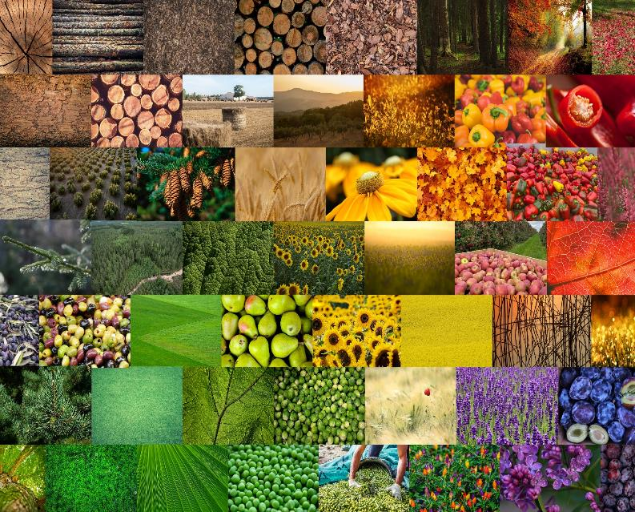

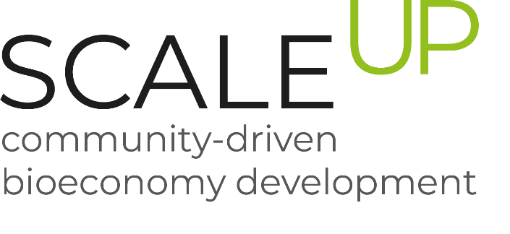

Minutes from the first regional platform meeting in Strumica
February, 2023

SDEWES-Skopje

Minutes for the first regional platform meeting

Event overview

The kick-off meeting for the regional platform in Strumica was organized on the 7th February, 2023 in the municipal premises. Eight representatives from the Municipality of Strumica, NGO Planetum and SDEWES-Skopje were participating this meeting.
The event consisted of two parts:
a) kick-off meeting and official start of the regional platform;
b) participation in a workshop on the topic "From digital transformation to innovation" organized by the Fund for innovation and technology development based on synergetic points related to the development of innovative business ideas in the field of agriculture sector.
Participants were introduced more in details about SCALE-UP project, its activities, regions and conceptual framework. Furthermore, an overview of the regional platform concept was given. By Introducing the Terms of Refence, the stakeholders were closely familiarized with the activities as members in the Strumica region.
The regional platform in Strumica region will be established within the Environment Department in the municipality of Strumica as a working group that would include people with diverse backgrounds such as ecologists, farmers, agricultural professors, advisors and entrepreneurs who are dealing with composting and treatment/collection of agricultural residues. The establishment of the platform will be formalized by a TOR signed by the members of the regional platform. The newly established regional platform would build upon the existing bioeconomy stakeholders panel and put additional focus on the promotion of biodegradability, assistance in applying for European and national funds, guidance to farmers for sustainable and circular agriculture and disposal of biodegradable waste with emphasis on the composting or other processing. Within the platform, the members will engage with the entire spectrum of bioeconomy stakeholders in the region, ensuring the effective exchange of knowledge and facilitating matchmaking among regional actors, and to oversee the implementation of targeted innovation support services.
The regional platform will be focused at:
• Maintaining a constant dialogue between different groups of stakeholders
• Harmonization of policies and measures in strategic and planning documents at the regional and national level
• Assistance in applying to relevant financial mechanisms
• Organization of seminars, educational events or other events related to a specific supply chain
• Organization of fairs and other promotional events
• Cooperation with the traditional Strumica festival and establishment of a corner for the promotion of the bioeconomy
• Identification of good bioeconomy examples and linkage in other regions in North Macedonia

Additionally, a mapping of existing documents and projects for bio-based value chains (composting) were conducted, a step which is crucial for further research and development in this regard. Some of the next steps were identified, such as:
• Signing the Term of Refence and Memorandum for Municipality of Strumica
• Defining additional members
• Supplementing the existing base of materials
• Identification of relevant projects and synergistic actions
o "With digital transformation to innovation", “Green ideas”, “Regional Center for Sustainable Development - Strumica and Vasilevo", etc
• Defining a business model for composting

Photos
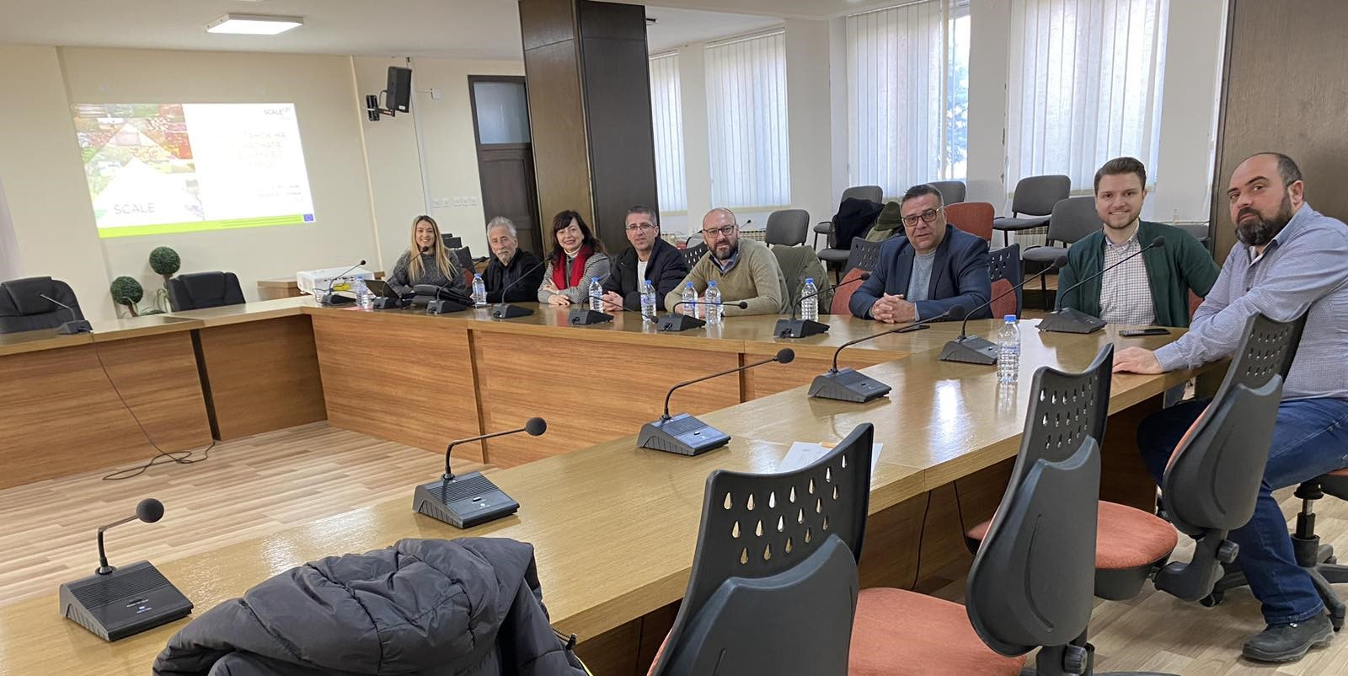

List of participants

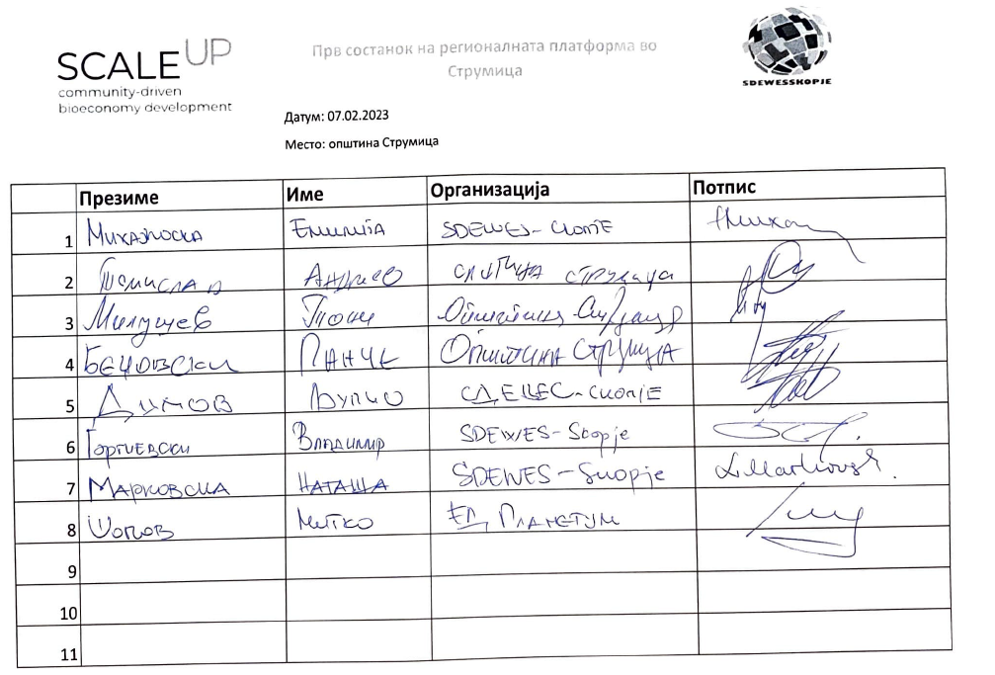

Supporting documents

Term of Refence
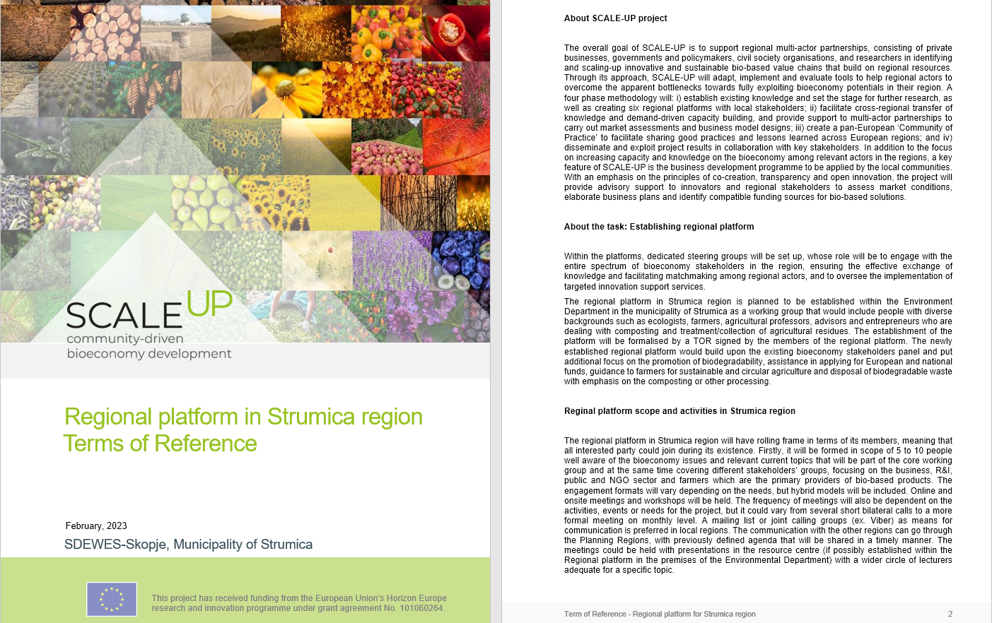
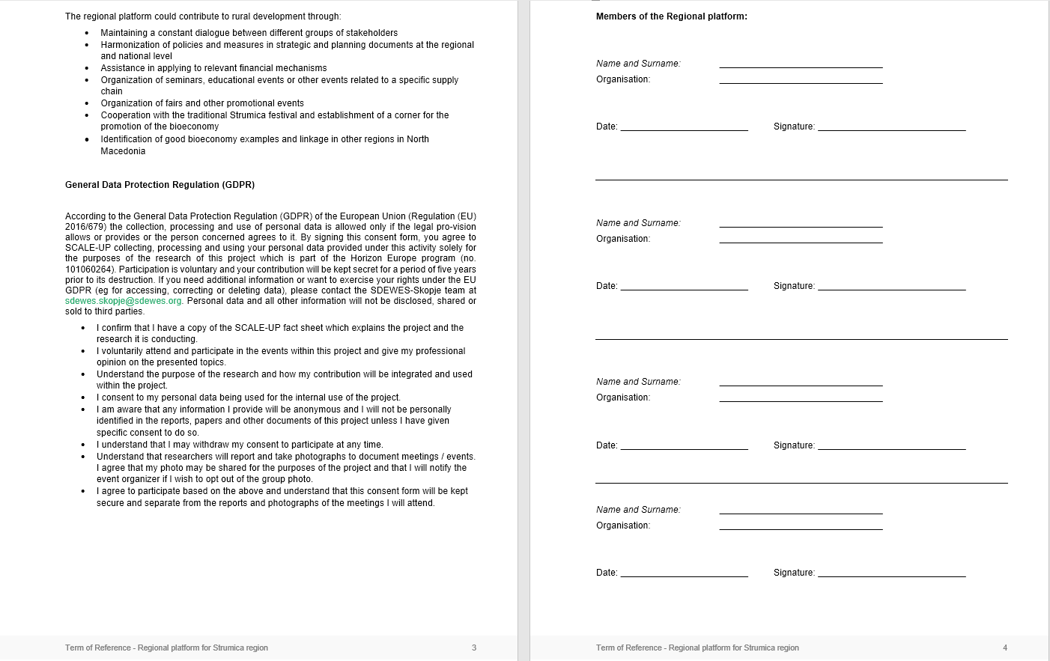

Presentation

Content
- Project summary, WP, scope, goals, conceptual frame, regions
- Regional platform in Strumica, as part of T5.1
- Structure, goals and activities for the regional platform
- Term of Refence for the members of the regional platform
- Mapping of existing documents and projects for bio-based value chains (composting)
- Next steps

