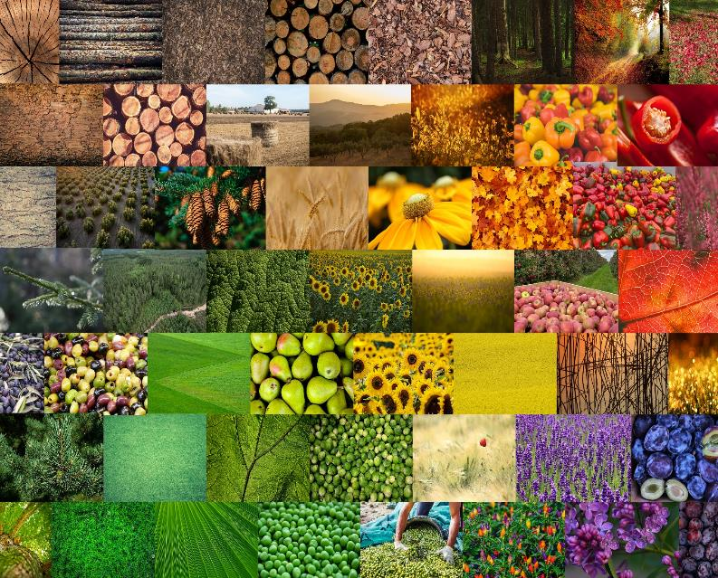

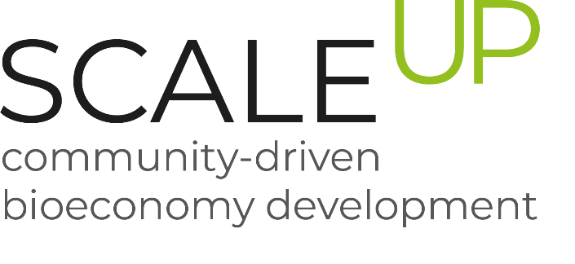

Minutes from the first regional platform meeting in Strumica
March, 2023

SDEWES-Skopje

Minutes for the second regional platform meeting

Event overview

The second meeting for the regional platform in Strumica was organized on the 28th March, 2023 in the Regional Center for Sustainable Development in Strumica and Vasilevo situated in the municipality of Strumica. Thirteen representatives from the Municipality of Strumica, NGO Planetum, NGO Hortieko, High School “Dimitar Vlahov” and SDEWES-Skopje were participating this meeting.
The event consisted of three parts:
- meeting with the mayor’s official representative and signing of the Memorandum for collaboration in the premises of municipality of Strumica
- info session for SCALE-UP promotion with the local TV media
- second meeting with the regional platform for bioeconomy in the Strumica in the premises of the Regional centar for sustainable development of Strumica and Vasilevo

The first part of the event was dedicated for the official establishing of collaboration between SDEWES-Skopje and Municipality of Strumica. Hence, with this the Regional platform for bioeconomy in Strumica is rightfully incorporated as part of the Environment Department within the municipality. On this occasion SCALE-UP’s aim and activities were presented and potential synergies with other ongoing projects on municipal level were communicated. The municipality of Strumica expressed their willingness to strengthen the collaboration, support the SCALE-UP project and enhance the bioeconomy on regional level.
In order to increase the visibility of SCALE-UP project on regional level, TV VIS was invited to be part of the promotional session of the project and to conduct an interview for further media dissemination about the regional platform for bioeconomy and the potential for development of innovative business bio-based model utilizing the local agricultural residues by creating added value products and services. Additionally, the promotional video was disseminated on national level as part of the news on TV Telma.
The working session with the regional platform covered the following aspects:
- Status of the regional platform and introducing 5 new members that are covering the public and academia sectors.
- Results and next steps of the analysis for the needs of the bioeconomy in the Strumica region
- Introduction of the training of 7 workstreams, its promotion and discussion on possible speakers and participants
- Biomass availability and overview of available documents and studies
- Development plan for the bio-based value chain and business models for composting
- Organization of a project meeting and study visit to the Strumica region (autumn 2023)
- Introduction of the call for identification of regional bio-based solutions by the Program for support of innovative bio-based value chain
- Next steps for mapping the primary – agricultural producers and secondary – processing industries for quantitative and qualitative overview of the available organic waste

Photos and media promotion
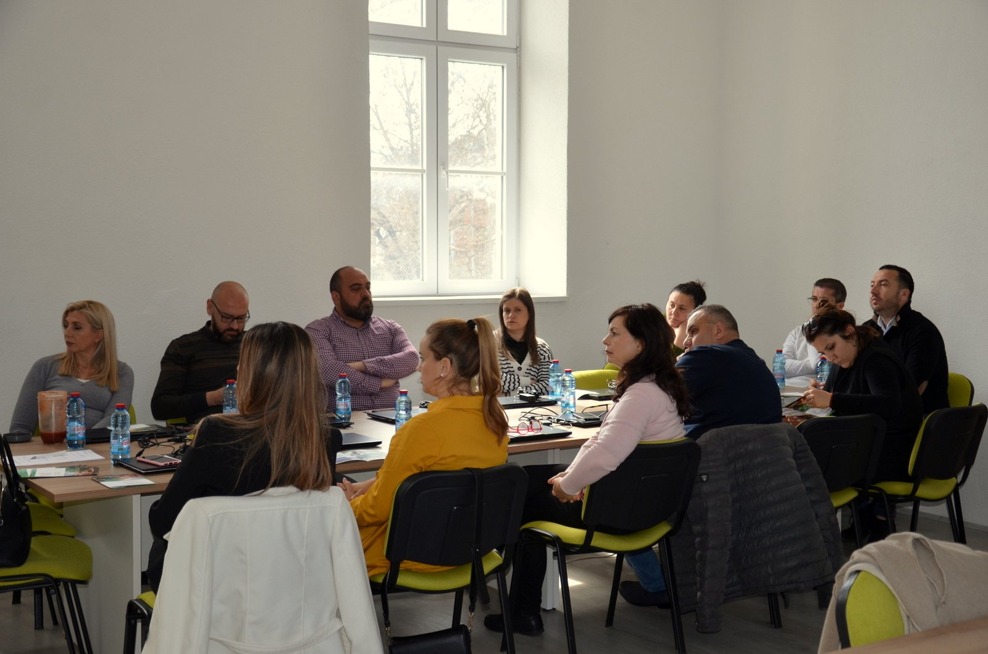
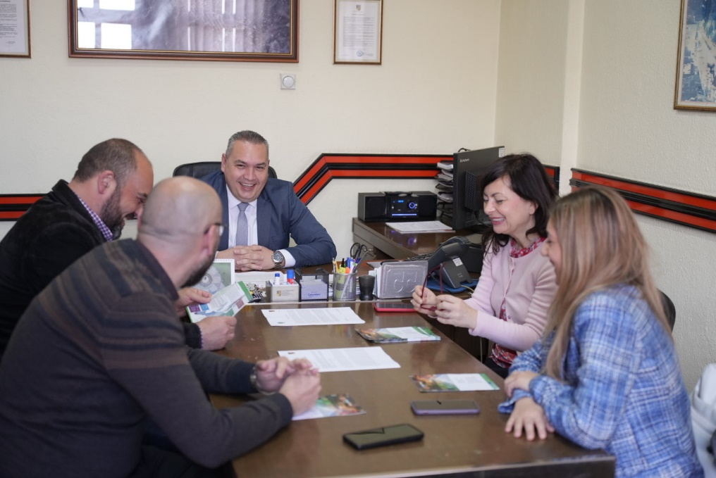

- TV Kanal VIS

- https://www.youtube.com/watch?v=TYZUmtVDv5U
- https://www.youtube.com/watch?v=4EGlJ6KDIwM

- Telma TV

- https://www.youtube.com/watch?v=sTQYLhKnvO8&list=PLQaTilgehBiRzNAQfhm-VdQWNH5HgF_gF&index=39

List of participants

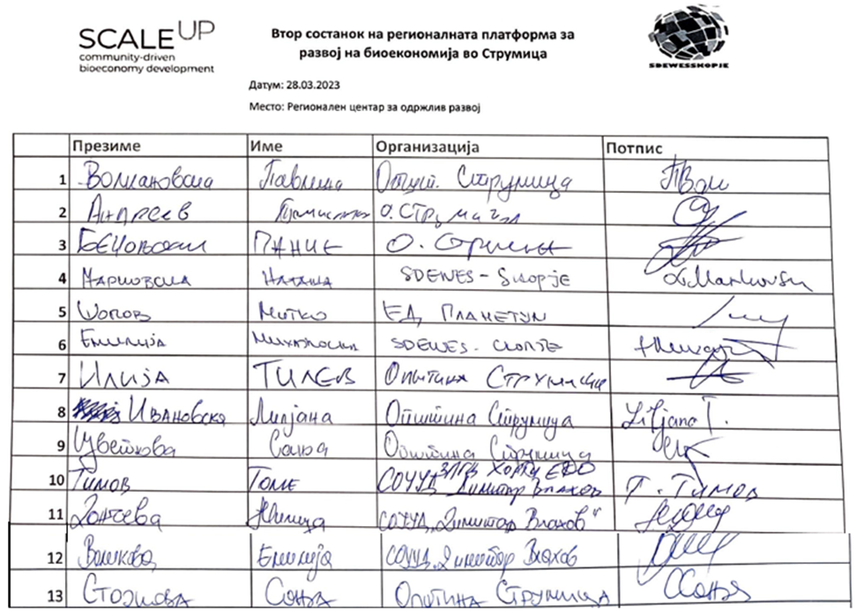

Supporting documents

Agenda
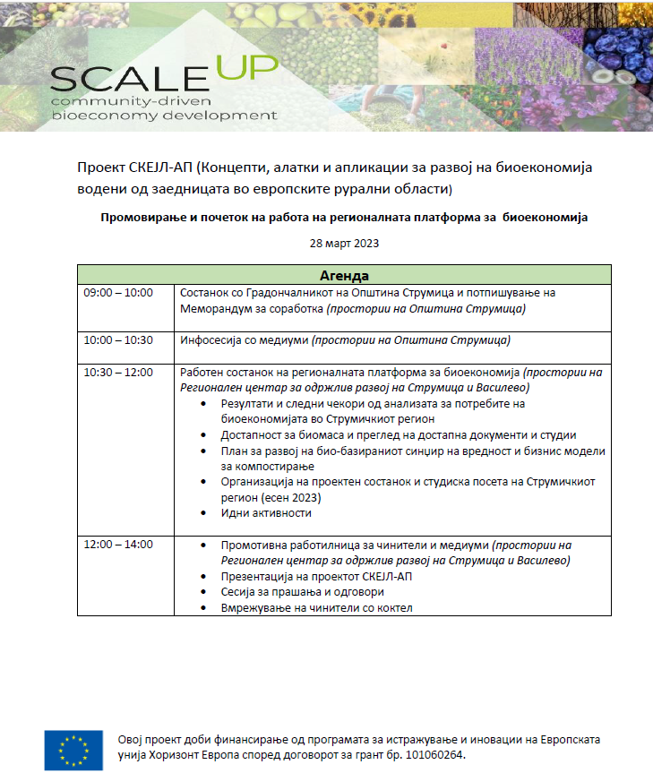

Memorandum

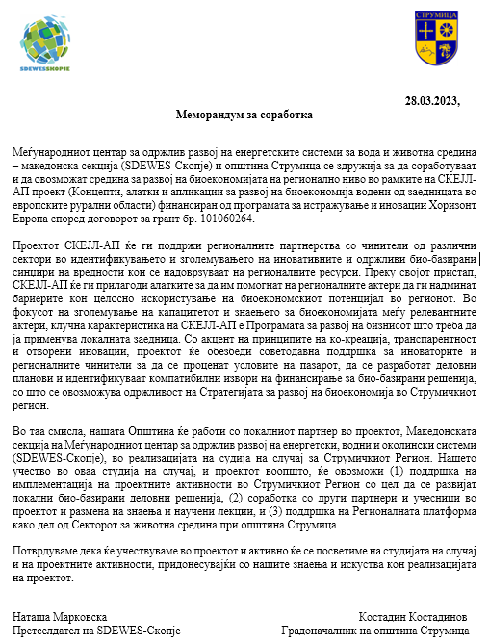

Presentation

Content
- Project summary, WP, scope, goals, conceptual frame, regions
- Regional platform in Strumica, as part of T5.1 and boarding new members
- Overview of the results from the survey of the analysis of the needs for bioeconomy in Strumica, promotion of the training session for the WS and discussion for potential speakers and participants for the respective WS
- Mapping of existing documents and projects for bio-based value chains (composting)
- Defining a plan for development of the bio-based value chain and business models for composting; starting point for mapping the primary and secondary residues streams (quantity and quality)
- Discussion on the possibility for organization of the study visit in Strumica in autumn, 2023 and drafting the initial agenda of the event
- Introduction of the Call for application: Programme for innovation support in the regional bio-based chain and brief explanation of its purpose
- Next steps

